|  |
| --- |
| Human computer interaction |
| Semitag – External Specifications Documents |
| Master M1 MOSIG, Grenoble Universities |
| TCHECHMEDJIEV Andon |
| TCHOUGOURIAN Tigran |
|  |
| **05/04/2011** |



|  |
| --- |
| **Supervisors :**  Gaëlle CALVARY  François BERARD |

|  |
| --- |
| The goal of this project is to put in practice the User Centered Design method for designing interactive computer applications. |

Contents

[1. Design 2](#_Toc289778587)

[1.1. User Model 2](#_Toc289778588)

[1.2. Environment Model 2](#_Toc289778589)

[1.3. Platform Model 2](#_Toc289778590)

[1.4. Task Model 2](#_Toc289778591)

[2. Detailed scenarios 2](#_Toc289778592)

[3. Interface descriptions 2](#_Toc289778593)

[3.1. General description 2](#_Toc289778594)

[3.2. The input form 3](#_Toc289778595)

[3.3. Search bar algorithm 5](#_Toc289778596)

[3.4. Results 5](#_Toc289778597)

[3.4.1. The Summary view 6](#_Toc289778598)

[3.4.2. The Details view 6](#_Toc289778599)

# Design

## User Model

The application is designed for novice user. Familiar with paper based forms.

## Environment Model

The application is provided by the semitag web site. It has to be accessible from any computer which has an internet connection and a web browser (Internet Explorer 9.0/Firefox 4.0/Chrome 10.0 from Windows, Firefox 4.0 for Linux, and Safari 5.0 for Mac)

## Platform Model

The application runs on Personal Computer web browser. It uses the mouse and the keyboard to navigate and get input.

## Task Model

# Detailed scenarios

# Interface descriptions

When the user arrives on semitag search patch functionality, one should be able to browse the answers in less than 2 click (submit click)

## General description

The function is divided in two frames as shown on the Figure 3-3. The A frame manage the input of the user, whereas the B frame manage the results.

Frames can be toggled up or down (Figure 3-1 and Figure 3-2) to not pollute the user view. When the user starts a new search, the frame B is completely hidden. Once the request submitted e.g. [3.2 The input form](#_The_input_form), the frame A is closed (only the title of the frame is visible) whereas the frame B is visible and the results appear.



Figure 3‑1: Open Frame

The user can always reopen the frame A to refine his path. That means that the frame A should remember the input values to help the user. The frame B has to be open during the refining phase, and reloaded with the new results after the user submits.

C:\Users\NargiT\Université\MoSIG M1\S8 - Human Computer Interaction\Projet\img\closeFrame.png

Figure 3‑2: Close Frame

[3.2 The input form](#_The_input_form) instantiate the frame A, whereas [3.4 Results](#_Results) instantiate the frame B.

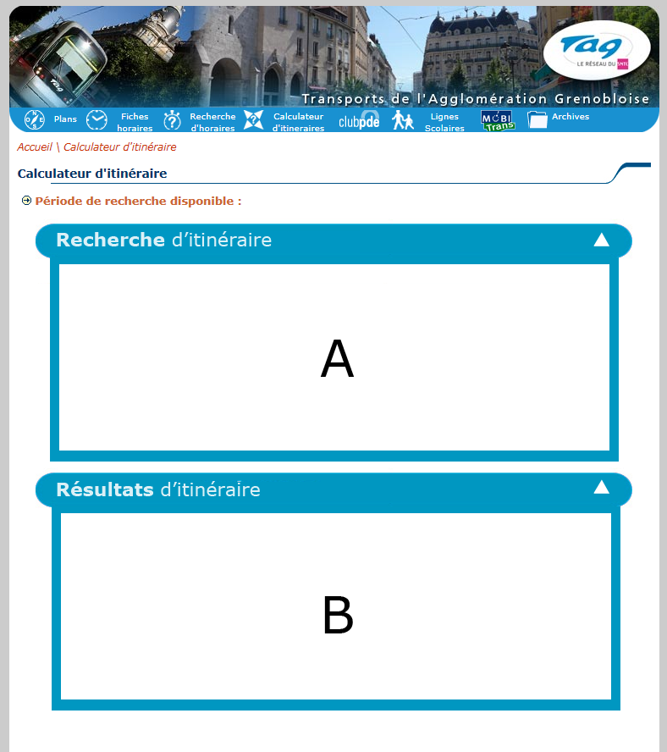

Figure 3‑3: General view of the function

## The input form

The input form is divided in 4 different information parts:

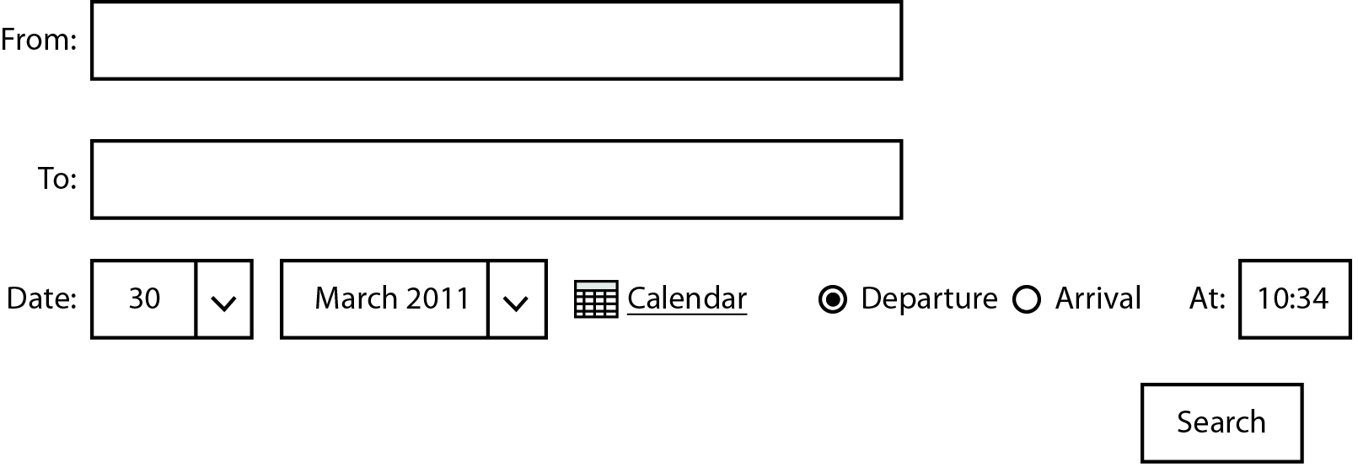

Figure 3‑4: Unique form to submit before to find an answer

* The “From” input field: indicates the source of the itinerary. The user set its departure. e.g. [Search Bar algorithm](#_Search_bar_algorithm).
* The “To” input field: indicates the destination of the itinerary. The user set its arrival. e.g. [Search Bar algorithm](#_Search_bar_algorithm).
* Date of usage: The user has two ways to set the date: With the drop down list or with a calendar script.
  + The drop list should respect the number of day for each month.
  + The calendar and the drop down lists are by default set to the current day.
* Sort of search: By default “Departure” is selected and “At” field is set to the current time + 5 min. The “Arrival” option represents the time that the user wants to arrive at the destination point. If the user clicks with the mouse to “Arrival”, it will automatically erase the content of “At” field and set the cursor on that field. If the user select back the “Departure”, then the cursor is set to the “At” field.
  + The “At” field should be enough smart to let the user only input numerical values and the “:” char.

Example:

|  |  |  |
| --- | --- | --- |
| Digits | Allowed | Transformed |
| 1 | 1 | 01:00 |
| 2 | 01 | 01:00 |
| 2 | 24 | 00:00 |
| 2 with colon | 01: | 01:00 |
| 2 with colon | 1:1 | 01:10 |
| 2 with colon | :10 | 00:10 |
| 3 | 100 | 10:00 |
| 3 | 230 | 23:00 |
| 3 with colon | 23:0 | 23:00 |
| 3 with colon | 1:10 | 01:10 |
| 4 | 1000 | 10:00 |
| 4 with colon | 10:00 | 10:00 |

Figure 3‑5: Input allowed and transformation

|  |  |
| --- | --- |
| Digits | Not allowed |
| 2 | 25 |
| 2 | 99 |
| 2 with colon | 25: |
| 2 with colon | 0:6 |
| 2 with colon | :60 |
| 3 | 250 |
| 3 | 106 |
| 3 with colon | 23:6 |
| 3 with colon | 1:60 |
| 4 | 2460 |
| 4 with colon | 10:60 |

Figure 3‑6: Corrupted input

The “search” button will submit the form if all the values are filled. If there is a missing field or a wrong data, a red rectangle has to surround the wrong field and the user has to redefine the new values. If for any reason the frame was close, it has to be open so the user can see the errors.

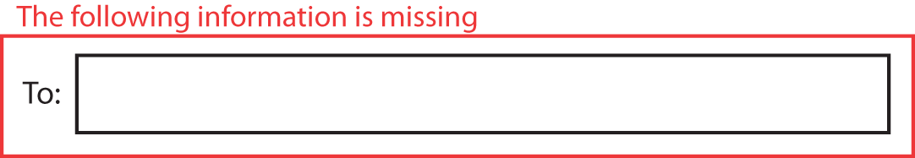

Figure 3‑7: A missing field

In case of the “From” and “To”, the red rectangle is appear if no matches were found. If there is multiple matches, then a drop down list will be available for the user to disambiguate.



Figure 3‑8: Possible Matches

## Search bar algorithm

The tool uses a form to get information about the source and destination address/station. The input field “From” and “To” are not simple input field because they uses an algorithm that find for the user the exact name of the address or station that they search. The algorithm autocompletes under the input field the best matches. It is an incremental search, which means that to avoid requesting the database to often it should starts to search after 3 char. At most 7 values are returned. The algorithm should always favour addresses as the first choice.

Each matching row is identifying with an icon on the right. A house represents an address, a bus represents a bus station, and a tramway represents a tramway station.

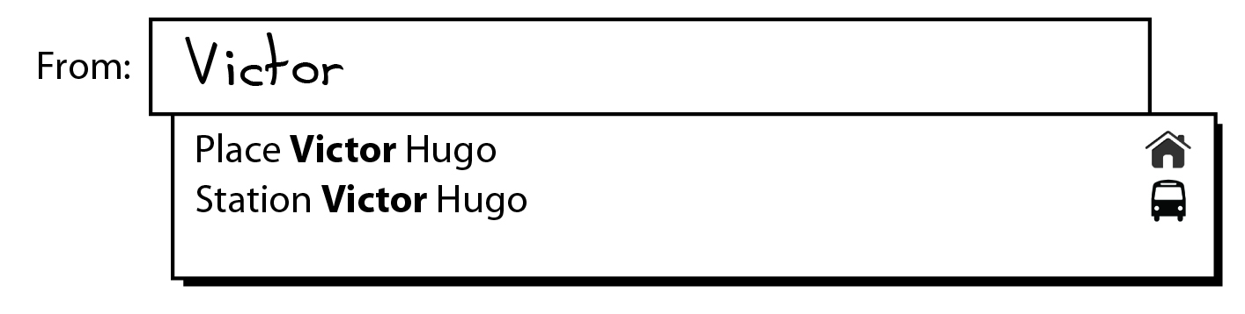

Figure 3‑9: A user tries to find a station or address with "Victor" inside

To help the user, the letters should which matches has to be bolded. Only the beginning of words should match, not letter inside a word.

Example:

A user searches for “André”. He starts to write “Andr”. The algorithm shouldn’t return Alex**andr**a

Signature of the function:

Precondition: String at least of length 3

Find (String address): List<Complete address, Image>

Postcondition: a list of 7 items at most, the item is composed of the full name of street/station and corresponding image (bus, house, tramway)

## Results

Once the input form finished and the form is submitted, frame A is toggled up and the frame B is toggled down. The results should be presented in the current form e.g. Figure 3-7. At most 3 results with different paths. They should be sorted by the departure time, and the first one should be selected.

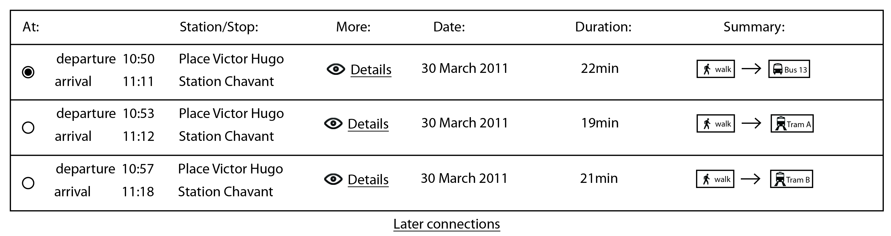

Figure 3‑10: The results

### The Summary view

C:\Users\NargiT\Downloads\1301477217_user_walk.pngThe “Summary” represents a fast way for the user to see what he/she should do during the trip.

A walking person is shown if one of the following actions has to be done by the user.

* The user has to go from one address to another one. If multiple address changes are performed, then the image is shown only once.
* The user has to go from one address to a station (bus or tramway).
* The user has to go from one station (bus or tramway) to another station (bus or tramway).
* The user has to go from one station (bus or tramway) to an address.



A bus with the identifier of the line is shown if one of the following actions has to be done by the user.

* The user has to take the bus

C:\Users\NargiT\Desktop\picto_train.png

A tramway with the identifier of the line is shown if one of the following actions has to be done by the user.

* The user has to take the tramway

The arrow represents the next step to be performed.

In the bottom of the Figure 3-10, the user can see the later connections. It just recalculates the itinerary with a new departure time or arrival time (if possible). Otherwise the later connection is hidden. In this version the function does not allow the user to see the previous connection, or to see earlier connection.

### The Detailed view

Each line can be opened to see in details the steps described in the summary. For that the user has to click on the eye or “Details”. The detailed view is also in the frame B, but is toggled down just under the selected line. If a user clicks again on the eye or “Details” the detailed view is toggled up and it comes back to the Figure 3-10.

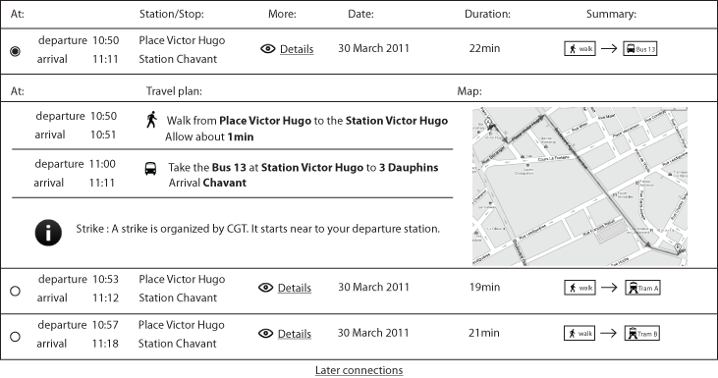

Figure 3‑11: Detailed view toggled down

As shown on the image bellow, a template is used to describe the “Travel plan”.

If a user has to walk from one address to another one, this is the template to use.

C:\Users\NargiT\Downloads\1301477217_user_walk.pngWalk from [address A] to the [address B]  
Allow about [time] min

C:\Users\NargiT\Downloads\1301477217_user_walk.pngIf a user has to walk from one address to a bus/tramway station, this is the template to use.

Walk from [address A] to the Station [station name]  
Allow about [time] min

If a user has to walk from one bus/tramway station to an address, this is the template to use.

C:\Users\NargiT\Downloads\1301477217_user_walk.pngWalk from [Bus|Tramway] Station [number of the bus] to [address]   
Allow about [time] min

If a user has to take a bus/tramway, this is the template to use.

C:\Users\NargiT\Desktop\picto_train.pngTake the [Bus|Tramway] at Station [station name] to [destination of the transport]   
Arrival [Bus|Tramway] [station name]  
Allow about [time] min

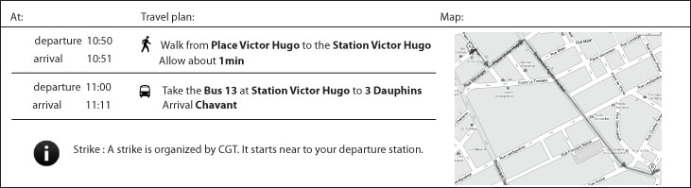

Figure 3‑12: Detailed view of one path

The information area is visible if there is any important news about the traffic. The information is set by the administrator of the web site.

The map is a global view of the trajectory that the user will use.